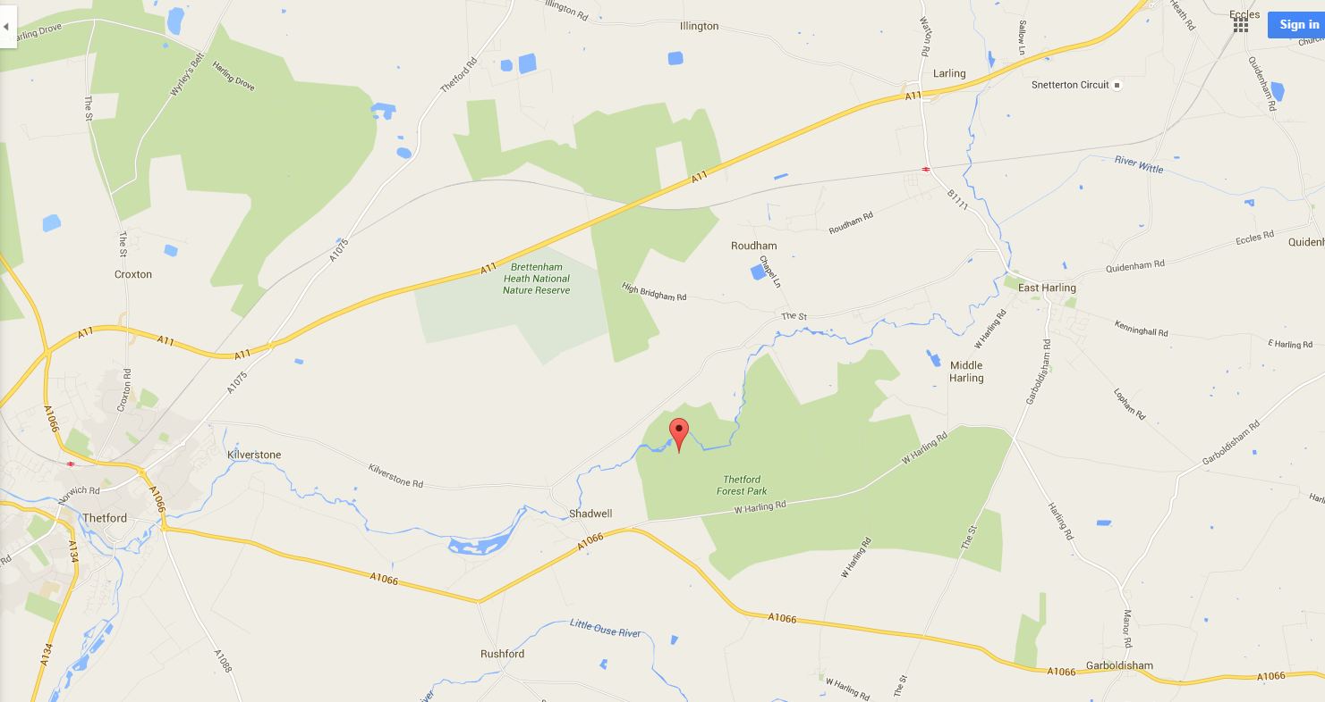
Please turn off West Harling Road and follow the track for both the Adventure Centre and Forest Holidays. We are half way down on the right hand side. If you’re visiting the main centre/activity day please park in the ‘Visitors Car Park’. If you’re visiting the Escape Pods please go further down the track and turn to the right signposted ‘Escape Pod Parking’.

